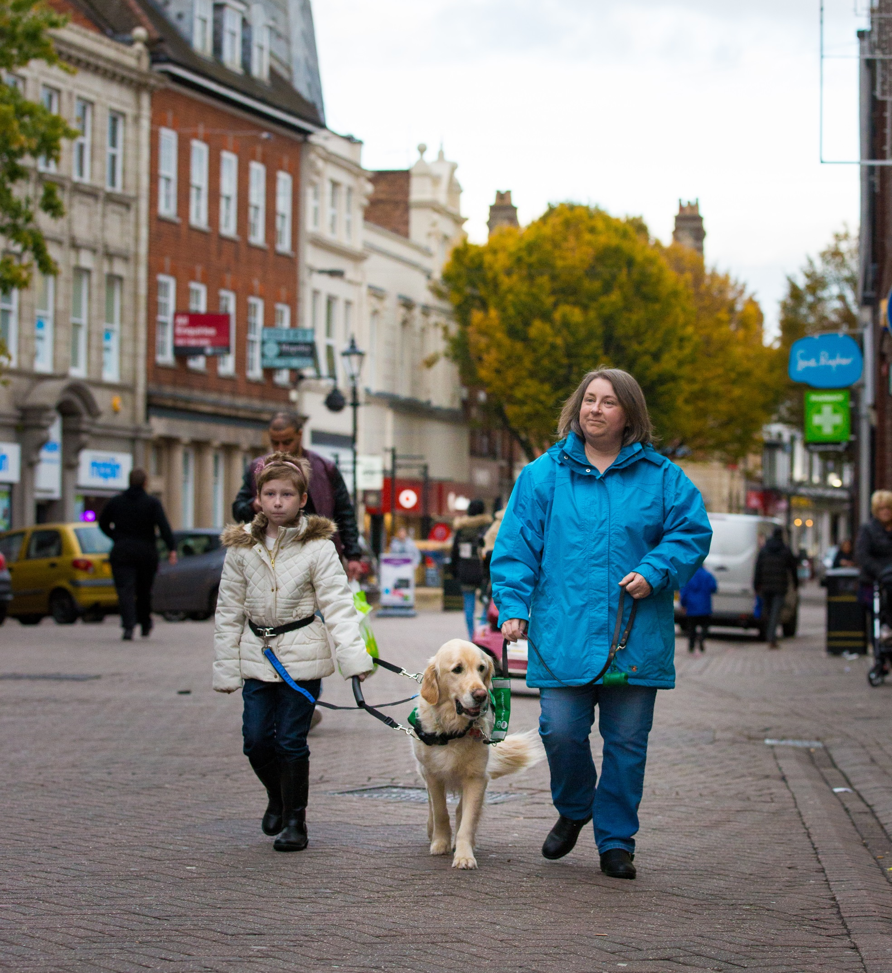



Application Form
Autism Assistance Dogs for Children

contents

Applicant Information
your life with a dog
Property details
Garden details
Vehicle information
TL employment information
TL voluntary Work
TL university/college information
your Child’s School details
health
weekly routine
free running
support network
dog experience
training course
other details
safeguarding
signatures & declaration

Please note that TL refers to Team Leader (responsible adult)

The definition of a TL and Facilitator can be found in the Autism Assistance Dogs for Children Guidance Notes

Please remember to refer to the Guidance Notes when completing this form. They will provide you with examples and the format needed to answer many of the questions. It is advisable to read through the Guidance Notes before completing the Application Form.

Should you run out of space to answer a question on the Application Form or need to provide us with extra information, please attach additional sheets to the back of this Application. Please note on these sheets the questions to which the additional information refers.

Dogs for Good Application

Applicant Information
TL Name (including title): |  |  |  |  |  |  |  |  |  |  |  |  |  |  | Date of Birth:
Child’s Name (including title): |  |  |  |  |  |  |  |  |  |  |  |  |  |  | Date of Birth:
Child’s Height: |  |  |  |  |  |  |  |  |  |  |  |  |  |  | Child’s Weight:
Tel (Home): |  |  |  |  |  |  |  |  |  |  |  |  |  |  | Mobile:
Tel (Work): |  |  |  |  |  |  |  |  |  |  |  |  |  |  | Email address:
Current residential address:
Town: |  |  |  |  |  |  |  |  | County: |  |  |  |  |  |  |  |  |  | Postcode:
Household residents:
Please note, applications from households with very young children / babies will be considered on a case by case basis
Name |  |  |  |  |  |  |  | Age |  |  |  |  | Relationship to TL |  |  |  |  | Please list any health conditions they have, including any autism spectrum disorders
Pets in household:
Please note, if you have a pet dog, there must be one handler per dog for lead walks, i.e. you will not be able to walk your pet dog(s) and assistance dog on lead together by yourself. This may mean walking your assistance dog separately, or having someone else with you who can handle your pet dog(s).

If you have 2 or more pet dogs, you must have another adult in the household who can assist with the dogs, so that you can focus on the assistance dog.

If your pet dog is not neutered, please let us know as this may affect whether you are accepted for an assistance dog, and the dog you are subsequently matched to. This will be decided following an assessment of your pet dog, and is to prevent any possibilities of a working dog being impacted by distractions such as; hormone levels, seasons, phantom pregnancies, etc. Please note if your dog/bitch is neutered we may ask for evidence of this in the form of veterinary notes.
Species |  |  |  |  |  |  |  | Age & Sex |  |  |  |  |  |  |  |  |  | Are they good with/used to dogs?
Please provide details of your facilitator:
Name:
Residential Address (if different from yours):
Town: |  |  |  |  |  |  |  |  | County: |  |  |  |  |  |  |  |  |  | Postcode:
Phone: |  |  |  |  |  |  |  |  | E-mail: |  |  |  |  |  |  |  |  |  | Fax:
Relationship to you:

Your life with a dog
How would you like your or your child’s life to change if you had a dog:
What skills or experience would you like to develop if you had a dog:
What activities would you or your family like to do if you had a dog:
How could a dog help you or your child inside and outside your home:
Where would you like to go with a dog:

Property Details
Property: Owned☐ Rented☐ Living With Parents☐

If your property is rented, you must provide written permission from your landlord/housing association to have an assistance dog at the property. This should include permission to have a dog in your home, as well as confirmation that the dog can use the garden for toileting off lead. It may be necessary for the garden to be made secure and accessible for you and a dog (e.g adding a gate), so permission should be obtained for this if appropriate. This is particularly important if your garden is communal.
If you move house in the future, it will be your responsibility to check the permissions and requirements of your new landlord, ensuring they are still suitable for you and an assistance dog.
Type of property: Detached☐ Semi-Detached☐ Flat – Ground☐ Flat – Upper☐ Bungalow☐ Sheltered Housing☐
Other (please detail):
Flooring found in property: Carpet☐ Stone/Tile☐ Wood/Laminate☐
Where will the dog sleep overnight:
Where will the safe space be located in the house (please provide pictures):
Please detail if you have any future plans to move (Planned timescale, where to):
Is there any building work occurring at the property / do you have any future plans for building work to take place – please provide details (Type of work, completion date):

Garden Details
Is the garden directly accessible from the house:

Yes ☐ No ☐

If no, state how you access the garden:
Is the garden communal:
Yes ☐ No ☐

If yes, do you have access to a safe and secure area for the dog to use for toileting within the communal garden?

Yes ☐ No ☐

If yes, please enclose written permission from your landlord that you are able to use the communal garden for a dog to toilet in and that they give you permission to install a toileting pen, if necessary.
Is the garden fully secure:

Yes ☐ No ☐

If not, please detail how it is not secure and indicate if you are prepared to make changes to secure it:
What is the height of the lowest part of any fencing in your garden (provide measurement):
What type of fencing do you have in your garden (e.g. panel, chicken wire, hedge):
What is on the other side of your fence? Please detail:
Are there any areas of your garden that you would not want a dog to access? If so, please detail:
What surfaces are found in the garden (tick all that apply):
Grass☐ Gravel☐ Woodchip☐ Concrete/Paving☐ Decking☐

What garden features are there (tick all that apply):

Pond☐ Water feature☐ Vegetable patch☐
Flower beds☐ Shed☐

Where and on what surface will the dog toilet:
If needed, are you prepared to install a toileting a pen:

Yes ☐ No ☐
If no, please detail reasons as to why:

Vehicle Information
Type of vehicle (e.g. Hatchback, Estate):
How will the dog travel in the vehicle:
Please detail any public transport that you currently use:
Type |  |  |  |  |  |  |  | Frequency |  |  |  |  |  |  |  |  |  | Duration
Please detail any public transport that you would intend to/like to use if you had a dog:
Type |  |  |  |  |  |  |  | Frequency |  |  |  |  |  |  |  |  |  | Duration
Will you be seeking permission to take your dog abroad with you? If so, please detail where, type of transport used and how often:

TL Employment Information
Current employer:
Mailing Address:
Town: |  |  |  |  |  |  |  |  | County: |  |  |  |  |  |  |  |  |  | Postcode:
Phone: |  |  |  |  |  |  |  |  | E-mail: |  |  |  |  |  |  |  |  |  | Fax:
Position:
How do you travel to work:
How long does it take to get there:
Hours of work:
 |  | Mon |  |  |  | Tues |  |  |  | Wed |  |  | Thur |  |  |  | Fri |  |  | Sat | Sun
Start Time
AM Break
Lunch Break
PM Break
Finish Time
Do you want to take your dog with you: (If no, skip to next section)
Yes ☐ No ☐
Do you have permission from your employer to take a dog to work with you:
Yes ☐ No ☐
Does your employer have any concerns about a dog attending with you:
Yes ☐ No ☐
If yes, what are the concerns:
Where and on what surface will the dog toilet:
Where will the dog be located during the day:
Can you meet the notice period and commitment to training times:
Yes ☐ No ☐

TL Voluntary Work
Organisation:
Mailing Address:
Town: |  |  |  |  |  |  |  |  | County: |  |  |  |  |  |  |  |  |  | Postcode:
Phone: |  |  |  |  |  |  |  |  | E-mail: |  |  |  |  |  |  |  |  |  | Fax:
Position:
How do you travel to your voluntary work:
How long does it take to get there:
Hours of work:
 |  | Mon |  |  |  | Tues |  |  |  | Wed |  |  | Thur |  |  |  | Fri |  |  | Sat | Sun
Start Time
AM Break
Lunch Break
PM Break
Finish Time
Do you want to take your dog with you: (If no, skip to next section)
Yes ☐ No ☐
Do you have permission from your voluntary work to take a dog to work with you:
Yes ☐ No ☐
Does your voluntary work have any concerns about a dog attending with you:
Yes ☐ No ☐
If yes, what are the concerns:
Where and on what surface will the dog toilet:
Where will the dog be located during the day:
Can you meet the notice period and commitment to training times:
Yes ☐ No ☐

TL university/college
University/College:
Mailing Address:
Town: |  |  |  |  |  |  |  |  | County: |  |  |  |  |  |  |  |  |  | Postcode:
Phone: |  |  |  |  |  |  |  |  | E-mail: |  |  |  |  |  |  |  |  |  | Fax:
Course:
How do you travel to University/College:
How long does it take to get there:
Hours of study/lectures (If known):
 |  | Mon |  |  |  | Tues |  |  |  | Wed |  |  | Thur |  |  |  | Fri |  |  | Sat | Sun
Start Time
AM Break
Lunch Break
PM Break
Finish Time
Do you want to take your dog with you: (If no, skip to next section)
Yes ☐ No ☐
Do you have permission from your University/College to take a dog on site with you:
Yes ☐ No ☐
Does your University/College have any concerns about a dog attending with you:
Yes ☐ No ☐
If yes, what are the concerns:
Where and on what surface will the dog toilet:
Where will the dog be located during the day:
Can you meet the notice period and commitment to training times:
Yes ☐ No ☐

your Child’s School details
School/College:
Mailing Address:
Town: |  |  |  |  |  |  |  |  | County: |  |  |  |  |  |  |  |  |  | Postcode:
Phone: |  |  |  |  |  |  |  |  | E-mail: |  |  |  |  |  |  |  |  |  | Fax:
Type of School: Main Stream ☐ ABA ☐ Autism Based ☐ SEN ☐
School Hours:
 |  | Mon |  |  |  | Tues |  |  |  | Wed |  |  | Thur |  |  |  | Fri |  |  | Sat | Sun
Start Time
Finish Time
Do you have permission to take your child out of school for training and aftercare visits:
Yes ☐ No ☐
Do you have permission to take a dog onto school grounds: (If needed)
Yes ☐ No ☐ Not needed ☐

Health
Child’s diagnosis:
Autism ☐ P.D.D ☐ C.D.D. ☐ Aspergers ☐
Please provide doctor’s/specialist records indicating your child’s diagnosis
Date of Diagnosis (MM/YYYY):
Please detail any secondary conditions they have:
Do you (the TL) have any health conditions, please detail:
Can you (the TL) maintain 3 hours of activity every day:
Please detail any specialist care your child receives and how often:
Are other care professionals (social workers, occupational therapists, physiotherapists) aware of your child’s application:
Does your child have:
 |  |  |  |  |  |  |  | Yes |  |  |  |  |  |  |  |  |  | No
Hearing Impairment |  |  |  |  |  |  |  | ☐ |  |  |  |  |  |  |  |  |  | ☐
Visual Impairment |  |  |  |  |  |  |  | ☐ |  |  |  |  |  |  |  |  |  | ☐
Epilepsy |  |  |  |  |  |  |  | ☐ |  |  |  |  |  |  |  |  |  | ☐
Seizures |  |  |  |  |  |  |  | ☐ |  |  |  |  |  |  |  |  |  | ☐
Diabetes |  |  |  |  |  |  |  | ☐ |  |  |  |  |  |  |  |  |  | ☐
Mental Illness |  |  |  |  |  |  |  | ☐ |  |  |  |  |  |  |  |  |  | ☐
Do you (the TL) have:
 |  |  |  |  |  |  |  | Yes |  |  |  |  |  |  |  |  |  | No
Hearing Impairment |  |  |  |  |  |  |  | ☐ |  |  |  |  |  |  |  |  |  | ☐
Visual Impairment |  |  |  |  |  |  |  | ☐ |  |  |  |  |  |  |  |  |  | ☐
Epilepsy |  |  |  |  |  |  |  | ☐ |  |  |  |  |  |  |  |  |  | ☐
Seizures |  |  |  |  |  |  |  | ☐ |  |  |  |  |  |  |  |  |  | ☐
Diabetes |  |  |  |  |  |  |  | ☐ |  |  |  |  |  |  |  |  |  | ☐
Mental Illness |  |  |  |  |  |  |  | ☐ |  |  |  |  |  |  |  |  |  | ☐
Describe your child’s:
Mobility
Physical Strength
Reaction Speed
Balance
Vision
Is your child:
Verbal ☐ Non-Verbal ☐

Method of communication used:
Please list any communication schemes used (e.g. PECS, Makaton):
Would your child find it beneficial to have a photo of any Dogs for Good staff before they visit your home?
Yes ☐ No ☐
Does you child:
 |  |  |  |  |  |  | Yes |  |  |  | No | If Yes please provide details
Have a dominant colour |  |  |  |  |  |  | ☐ |  |  |  | ☐
Have a current ongoing obsession |  |  |  |  |  |  | ☐ |  |  |  | ☐
Please tell us about your child’s wandering and/or bolting behavior (see the Guidance Notes for definitions)
 |  |  |  |  | Wandering |  |  |  |  |  |  |  |  |  |  | Bolting
Does your child display this behavior? |  |  |  |  | Yes ☐  No ☐ |  |  |  |  |  |  |  |  |  |  | Yes ☐  No ☐
Where do they do it? |  |  |  |  | Inside the home ☐  Outside the home ☐  Both ☐  Other: |  |  |  |  |  |  |  |  |  |  | Inside the home ☐  Outside the home ☐  Both ☐  Other:
What causes them to do it? |  |  |  |  | Anxiety ☐  Fear ☐  To get to something they want ☐  Gets distracted ☐ |  |  |  |  |  |  |  |  |  |  | Anxiety ☐  Fear ☐  To get to something they want ☐  Gets distracted ☐
How do they do it? |  |  |  |  | Walk slowly ☐  Walk quickly ☐  Run ☐ |  |  |  |  |  |  |  |  |  |  | Walk slowly ☐  Walk quickly ☐  Run ☐
Does you child use a buggy or stroller to access certain areas/environments:

Yes ☐ No ☐

If yes, what percentage of the time is your child in a buggy or stroller when outside of the house:

10% or less ☐ 10%-25% ☐ 25%-50% ☐ Over 50% ☐

Is your child receiving any prescribed medication:
Yes ☐ No ☐
If yes, please detail:
Are you (the TL) receiving any prescribed medication that could affect your ability to train with a dog:
Yes ☐ No ☐
If yes, please detail:
Please indicate any additional sensitivities affecting your child:
 |  |  |  | How it affects them
Sound
Light
Touch
Other:

Weekly Routine
Please complete the following tables to outline your weekly routine:
Monday | TL |  |  |  |  |  |  |  |  |  |  |  |  | Child
06.00
07.00
08.00
09.00
10.00
11.00
12.00
13.00
14.00
15.00
16.00
17.00
18.00
19.00
20.00
21.00
22.00
23.00
Environments encountered during this day:
Tuesday | TL |  |  |  |  |  |  |  |  |  |  |  |  | Child
06.00
07.00
08.00
09.00
10.00
11.00
12.00
13.00
14.00
15.00
16.00
17.00
18.00
19.00
20.00
21.00
22.00
23.00
Environments encountered during this day:
Wednesday | TL |  |  |  |  |  |  |  |  |  |  |  |  | Child
06.00
07.00
08.00
09.00
10.00
11.00
12.00
13.00
14.00
15.00
16.00
17.00
18.00
19.00
20.00
21.00
22.00
23.00
Environments encountered during this day:
Thursday | TL |  |  |  |  |  |  |  |  |  |  |  |  | Child
06.00
07.00
08.00
09.00
10.00
11.00
12.00
13.00
14.00
15.00
16.00
17.00
18.00
19.00
20.00
21.00
22.00
23.00
Environments encountered during this day:
Friday | TL |  |  |  |  |  |  |  |  |  |  |  |  | Child
06.00
07.00
08.00
09.00
10.00
11.00
12.00
13.00
14.00
15.00
16.00
17.00
18.00
19.00
20.00
21.00
22.00
23.00
Environments encountered during this day:
Saturday | TL |  |  |  |  |  |  |  |  |  |  |  |  | Child
06.00
07.00
08.00
09.00
10.00
11.00
12.00
13.00
14.00
15.00
16.00
17.00
18.00
19.00
20.00
21.00
22.00
23.00
Environments encountered during this day:
Sunday | TL |  |  |  |  |  |  |  |  |  |  |  |  | Child
06.00
07.00
08.00
09.00
10.00
11.00
12.00
13.00
14.00
15.00
16.00
17.00
18.00
19.00
20.00
21.00
22.00
23.00
Environments encountered during this day:
Please detail any other regular events/appointments/commitments you attend:

Free RunNing
Please list the areas that you intend to free run your dog. The Guidance Notes provide information that can help you decide on a sufficiently secure free run area (provide pictures if possible):
Are you prepared to ensure that the dog is exercised every day regardless of the weather, schooling and childcare commitments:

Yes ☐ No ☐

Please detail how you will ensure the dog is exercised each day:

Support Network
Please list at least two people that will be able to look after a dog at short notice. You will need to ensure that their house and garden are secure for a dog and that they are able to look after the dog as instructed. It is preferred that at least one of your nominees does not share the same address as you, and that they live no more than 2 hours from you. Confirmation in writing will be required from them:
Name |  |  |  | Address |  |  |  |  |  |  |  |  |  |  |  |  |  |  | Phone

Dog Experience
Have you owned a dog before:
Yes ☐ No ☐
Have you had exposure to dogs? If so, please detail:
Has your child had exposure to dogs? If so, please detail:
Is your child able and happy to give treats to a dog by hand:
Are you happy to accept any dog that the Charity identifies as being suitable regardless of breed, sex, colour:
Yes ☐ No ☐
If no, please detail:
If you had a dog, which veterinary practice would you use:
Practice name:
Mailing address:
Town: |  |  |  |  |  |  |  |  | County: |  |  |  |  |  |  |  |  |  | Postcode:
Phone: |  |  |  |  |  |  |  |  | E-mail: |  |  |  |  |  |  |  |  |  | Fax:

Training Course
Are you (the TL) able to attend a (minimum) 5 day residential training course at one of our centres:
Yes ☐ No ☐
If no, please explain why:
What care arrangements will you need for a stay away:
Please provide details of your emergency contact (this needs to be someone who would not attend the training course with you):
Name:
Residential address:
Town: |  |  |  |  |  |  |  |  | County: |  |  |  |  |  |  |  |  |  | Postcode:
Phone: |  |  |  |  |  |  |  |  | E-mail: |  |  |  |  |  |  |  |  |  | Fax:
Phone:
Relationship to you:

other INFORMATION
Please list any dates of upcoming holidays or appointments where you would be unavailable for training:
What prompted you to apply:
Have you applied for, had or been declined an Assistance Dog from another charity:
Yes ☐ No ☐
If yes, please detail:
Is there anything else that you would like to tell us/make us aware:

safeguarding
Do you have any unspent criminal convictions, police cautions, reprimands or warnings or do you have any criminal cases pending against you?
Yes ☐ No ☐
If yes, please provide details:

Signatures
By signing below, I understand and confirm that:

- To the best of my knowledge, all the information submitted on this form is true, accurate and complete at the time of writing.

- I have read and agree to the Charity’s Privacy Policy. This enables the Charity to perform its responsibilities, respond to your request, and decide if we can help you in the way you need. The Charity will collect and process certain personal data relating to you in accordance with the attached Privacy Policy. This Policy may be updated from time to time in which case you will be notified of changes.

- Dogs for Good shares a commitment to safeguarding and promoting the welfare of children, young people and vulnerable adults. The Charity’s commitment is underpinned by robust processes and procedures that seek to maximise opportunity, minimise risk and continuously promote a culture that embraces the ethos of safeguarding amongst its workforce.

Signature of Team Leader: |  |  |  |  |  |  |  |  |  |  |  |  |  |  |  |  |  |  | Date:

